Migration and Implementation Road Map

Agenda:
Identify different projects.
Quantify different projects (CBA).
CBA – (Cost / Return of investment)
Include possible alternatives (outsource/in-house, infrastructure lease/owned)
Risk
Schedule (Timeline)
Project clustering (dependencies)
Asset Management
Project prioritization matrix. Diagram
Project bubble (value to risk (Man Hrs as size of the bubble)). Diagram
Transition Assessment.
Transition Initiatives (Phases based on the project clustering)
Transition Roadmap (Business, Data, Solution & Technical). Diagram
Transition Implementation Business Case. (phase)
Resources.
Budget.
Transition Schedule (Timeline & Ownership)
Detailed project planning. (Phases of the transition)
Implementation road map. (Consolidated to all phase)
IT Portfolio Management.
How to coordinate? Providing decision making guidelines to the transition phases.
(e.g., risk tolerance, funding and resource capacity and constraints; cost limitations, must-have versus nice-to-have requirements, investment categories)

Identify different project:
1. SCBS
2. VCMS
3. Shipment Tracking (ShipTrack System)
4. ESB
5. MQ for HRS
6. MQ for AFIS
7. Interface Engine
8. Web Portal
9. Management Reports

Quantify different projects:
1. SCBS
Sales order and customer billing system, this is a must-have requirement. As proposed to be a central system, with high degree of data integrity.
Major Costing:
Infrastructure:
Server: Windows Server 2012 Operating System (Blade Servers)
Cost: 20000 SGD (Investment for 5 Years)
Yearly Maintenance: Around 2000 SGD.
Internet: 2000 SGD (Investment for every year)
Application Development/Rollouts:
In-house Model
Database licensing:
Oracle: 35000 SGD (Standard) 11g
Resource:
Man Hours: 2880, 3 Months – (4 developers)
Cost: 100800 @ 35 SGD / Man Hr
Dependency:
ESB
Risk:
Compatible to the existing system integration.
Data migration.
Value & Benefits:
Reduce response time to customer queries.
Reduce time spending customer complaints.
Man power reduction. (Complaints Checks/Phone call to record the order)

Reduce 3 hr/day of man power, for 3 customer service representatives to record the purchase order over phone or by fax.
Saving, 64800 SGD per year @ 20 SGD man hr cost

2. VCMS
It is the central integrated system for the vessel and the container movement system. This is an operational system and categorized as a critical system and belongs to must-have requirement.

Major Costing:
Infrastructure:
Shares the infrastructure and maintenance cost for the server as of the technology architecture.
Application Development/Rollouts:
In-house Model
Database licensing:
Shares the investment cost for the database as of the central system defined by the technology architecture.
Resources:
Man Hours: 3840, 4 Months – (4 developers)
Cost: 134400 @ 35 SGD / Man Hr
Dependency:
ESB
Value & Benefits:
Reduce response time. (Time to market)
Man power reduction. (Manual Checks)
Improve quality.

Reduce 2 hr/day of man power, for 2 operations experts on checking the manual data verification.
Saving, 43200 SGD per year @ 30 SGD man hr cost

3. Shipment Tracking (ShipTrack System)
It is a web implementation exposed to customers to track the shipping entity status. This is a must-have requirement.

Major Costing:
Infrastructure:
Shares the infrastructure and maintenance cost for the server as of the technology architecture.
Application Development/Rollouts:
In-house Model
Database licensing:
Shares the investment cost for the database as of the central system defined by the technology architecture.
Resources:
Man Hours: 960, 2 Months – (2 developers)
Cost: 33600 @ 35 SGD / Man Hr
Dependency:
VCMS (to track operations status) and SCBS (to track the delivery status)
Value & Benefits:
Reduce response time to customer queries.
Reduce time spending customer complaints.
Man power reduction. (Complaints and tracking the shipment status checks)

Reduce 1 hr/day of man power, for 2 customer representative to check the shipping status.
Saving, 14400 SGD per year @ 20 SGD man hr cost

4. ESB
We have proposed to implement as the open source, also enclosed a supportive result to make a decision.

Major Costing:
Infrastructure:
Shares the infrastructure and maintenance cost for the server as of the technology architecture.
Application Development/Rollouts:
Vendor selection: Plan is to consider the potential of an open source ESB and upgrade to more robust solutions as need arise. (MuleSoft)
In-house Model (Opportunities and Solutions)
Orchestrations of the applications for the integration are done as a part of the setting up the ESB. The further adding/removing the message registers is done as a part of the maintenance.
Resources:
Man Hours: 480, 1 Months – (2 developers)
Cost: 16800 @ 35 SGD / Man Hr

5. MQ for HRS/AFIS
These applications can be integrated using the MQ-Message Queuing, to the ESB for the enterprise integration. It is a nice to have requirement.

Major Costing:
Application Development/Rollouts:
In-house Model
Resources:
Man Hours: 480, 1 Months – (2 developers)
Cost: 16800 @ 35 SGD / Man Hr

6. Interface Engine, Management Reports and Web Portal
These are related to the primary interfaces for the major systems (VCMS, SCBS and Shipping tracking).

Major Costing:
Infrastructure:
Shares the infrastructure and maintenance cost for the server as of the technology architecture.
Application Development/Rollouts:
In-house Model
Database licensing:
Shares the investment cost for the database as of the central system defined by the technology architecture.
Resources:
Man Hours: 1920, throughout the transition (2 months & 4 developers)
Cost: 67200 @ 35 SGD / Man Hr
Dependency:
VCMS (to track operations status) and SCBS (to track the delivery status)
Value & Benefits:
Customer satisfaction and increase in customer retention.
Support B2B applications, using the Interface Engine. (Mass responses)
Benefit @40000~ 100000 per year.
 | Year 1 | Year 2 | Year 3 | Year 4 | Year 5
Capital Cost (Infrastructure) | 55000 | 0 | 0 | 0 | 0
Capital Cost (Development) | 369600 | 0 | 0 | 0 | 0
Yearly Maintenance Cost | 10000 | 10000 | 10000 | 10000 | 10000
Savings | 0 | 162400 | 182400 | 202400 | 222400
Expenses | 434600 | 282200 | 109800 | -82600 | -295000
ROI | 0 | 0 | 0 | 82600 | 295000

Project Initiatives | Category | Strategic Impact | Financial Impact | Risk | Opportunities for  early success | Alignment with  current initiatives | Resource Requirements | Dependency | Overall Priority Rank
1. SCBS | Business | H | H | H | L | M | H | M | H-3
2. VCMS | Business | H | H | H | M | M | H | M | H-2
3. Shipment Tracking (ShipTrack System) | Business | H | M | M | M | L | H | M | H-4
4. ESB | Solution | M | L | M | M | L | L | H | H-1
5. MQ for HRS | Technical | L | L | L | H | H | L | M | L-8
6. MQ for AFIS | Technical | L | L | L | H | H | L | M | L-9
7. Interface Engine | Solution | M | L | M | H | L | M | H | M-5
8. Web Portal | Information | M | L | M | H | M | M | H | M-6
9. Management Reports | Information | M | M | M | H | M | M | M | M-7

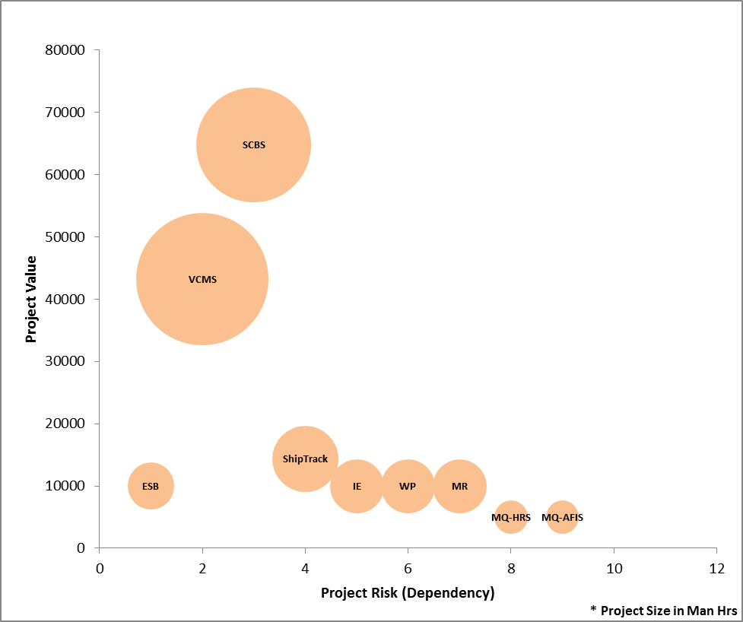

Transition Initiatives

Phase 1: (1-6 Months)
The following are the project clusters that have higher dependency to go live together with good benefits in values for the first phase. This also facilitates the seamless integration capability with account to the decommissioning of existing system.
- ESB,
- VCMS, Data migration for VCMS, VCMS Compatibility support to existing systems,
- Management Reports,
- Interface Engine and
- Web portal.
Phase 2: (4-10 Months)
The following are the project clusters that have next higher dependency with less risk to the earlier phase; this also facilitates an enterprise level integration.
  - SCBS, Data migration for SCBS,
  - Shipment Tracking,
  - Management Reports,
  - Interface Engine and
  - Web portal.
Phase 3: (6-12 Months)
The less prioritized projects, moderate business values with low risk, follows the legacy systems that to integrate using ESB.
  - MQ implementation for HRS and AFIS,
  - Management Reports,
  - Interface Engine and
  - Web portal.
 | Projects | Ownership
Phase 1 | ESB | IT/Operations
Phase 1 | VCMS | Container Management Team
Phase 1 | IE | IT/Operations
Phase 1 | Web portal | Container Management Team
Phase 1 | Reports | Container Management Team
Phase 2 | SCBS | Order Processing Team
Phase 2 | ShipTrack | Order Processing Team
Phase 2 | IE | IT/Operations
Phase 2 | Web portal | Order Processing Team
Phase 2 | Reports | Order Processing Team
Phase 3 | MQ HRS | HR & Finance Team
Phase 3 | MQ AFIS | HR & Finance Team
Phase 3 | IE | IT/Operations
Phase 3 | Web portal | HR & Finance Team
Phase 3 | Reports | HR & Finance Team

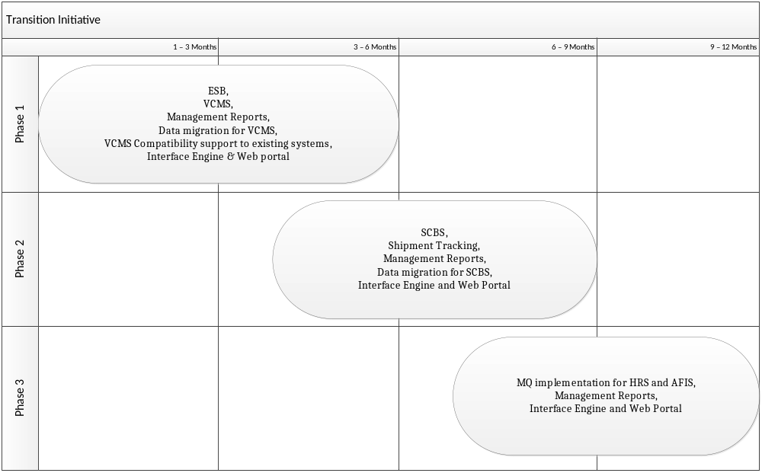

Transition Road Map:
The road map that defines the section of business, application, information and technology architecture that has to be implemented in each phase.
Business Architecture by Phases:

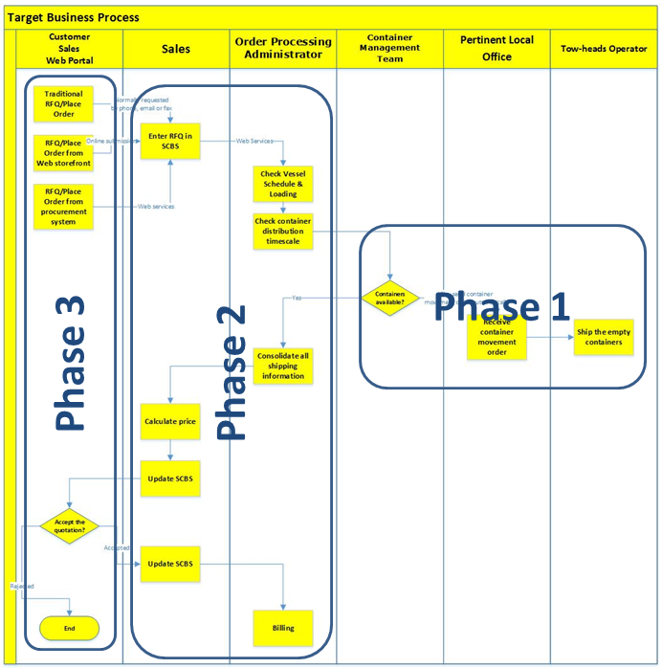

Application Architecture by Phases:

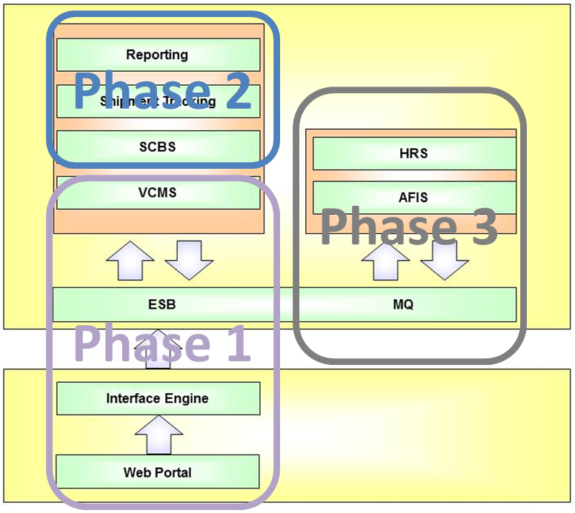

Information Architecture by Phases:

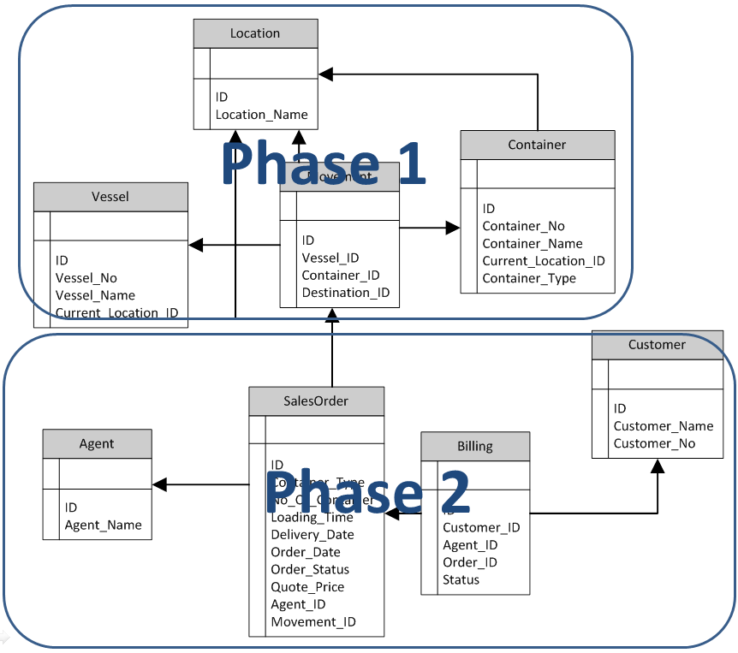

Technology Architecture by Phases:

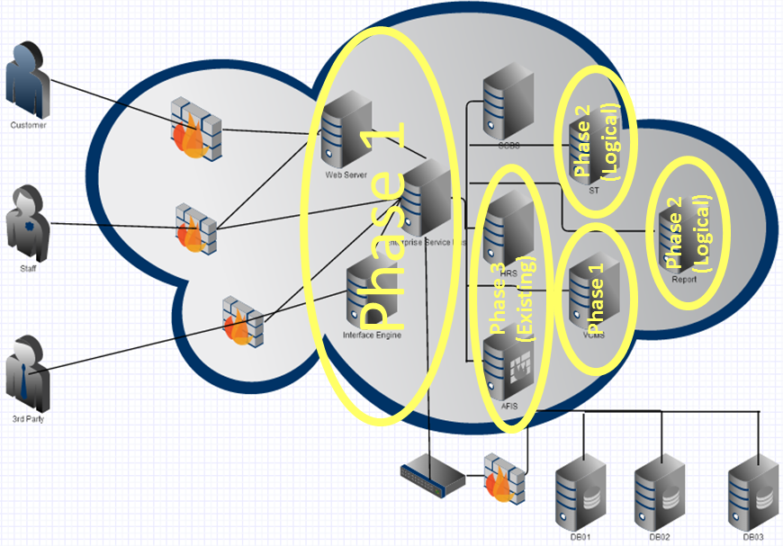

Transition Business Case: (Purchase justify to management against the benefits to the business value)

Phase 1:

Infrastructure:

Windows Server 2012: (http://windowsserver2012.itpro.co.uk/business-benefits/78/how-make-business-case-windows-server-2012/page/0/2)
- Moving from a physical infrastructure to a virtualized one is bread-and gives massive cost savings by extending the life of existing kit and reducing the cost of buying new simply by decreasing the amount you need to buy and support.
- If you have branch offices, the in-built WAN optimization features will let you wait longer before upgrading your WAN links to cope with data growth, and cost you less than buying WAN optimization appliances and Direct Access for mobile working
- PowerShell 3.0 is a very big deal. For the first time you get proper Unix-power scripting capabilities, including tools such as web services and proxies for remote control. Scripting equals less human error, more automation, and hence lower downtime and support costs.
- If your processing requirements vary and you opt to use the cloud to fill the gap between your in-house day-to-day processing requirements and fluctuating additional needs, you can manage the in-house and outsourced services under the same umbrella. This means more time saved, less need to buy hardware for in-house installation, and a more seamless (and hence less time-consuming and manual) experience for users.
- Although there's no guarantee for any IS trend, recent acquisition behavior in the industry shows that network virtualization is going to be a big deal, and is going to save money through all the usual mechanisms (easier, less time-consuming management, less equipment, lower bandwidth requirements, and so on). As there's not yet a clear leader, it makes a lot of sense to consider putting your money on the one that's already integrated with the OS family you use, and is developed as an integral part of that OS family.

Database:

Oracle: (http://www.eit-uk.co.uk/Oracle-11g.html)
ROI benefit - improved database performance

11g offers improved performance in a variety of areas; it also offers data compression. Together, these factors could extend the life of both your servers and your storage. In addition, Active Data Guard can make use of an otherwise dormant backup system.

Oracle Database 11g introduces many performance breakthroughs. New server and client-side result caching has improved the performance of often-repeated statements by 25% or more. New native compilers for PL/SQL and Java have drastically improved performance, up to 2 times faster for PL/SQL and 11 times faster for Java.
Reduced Storage Needs - Oracle Advanced Compression offers a comprehensive set of compression capabilities for all data types, significantly reduces database storage for structured, unstructured, and backup data. While storage costs are an obvious tangible benefit of compression, memory efficiency is enhanced as data in memory is in a compressed format. This allows more data to be stored in memory and reduces the number of I/Os, which may improve performance.
Oracle Active Data Guard enables customers to use their standby database to improve performance in their production environments. By offloading workloads from production to a standby system, Oracle Data Guard helps enhance the performance of production systems and provides a more cost-effective disaster recovery solution
Improved DBA productivity

Oracle Diagnostics Pack 11g: Diagnosing a slowly performing system is a time consuming task. Oracle Diagnostics Pack 11g is a self-diagnostic solution that enables Oracle Database 11g to automatically monitor and diagnose its performance problems, thereby liberating administrators from this difficult and arduous task.

Oracle Tuning Pack 11g: A poorly tuned business application can potentially affect not just a few users but an entire business operation. For this reason companies invest significant resources to ensure smooth running of applications vital for their businesses. Oracle Tuning Pack 11g offers a cost effective solution that automates application and SQL tuning and eliminates the need for manual tuning. System performance and reliability are enhanced and management costs are significantly lowered.

Functional Benefits

Oracle Real Application Testing: System changes such as hardware/software upgrades and patch applications are essential for businesses to maintain a competitive edge. Such changes can lead to unexpected and undesirable behavior. Often, despite extensive testing, many problems are only detected on production deployment, resulting in unplanned downtime and loss of revenue. Oracle Real Application Testing combines a workload capture and replay feature with a SQL performance analyzer to help test changes against real-life workloads. Testing time is reduced and testing accuracy is improved, resulting in lower production deployment risk and decreased business costs.
Data security and compliance (1): Oracle Advanced Security provides an easy-to-deploy and comprehensive solution for protecting all communication to and from an Oracle Database, providing both native network encryption and SSL based encryption.
Data security and compliance (2): Oracle Database Vault controls the who, when, and where of data and applications that can be accessed – protecting a business against the most common security threat: malicious internal users. It achieves this by controlling access to application and database data, even by highly privileged users.

ESB:
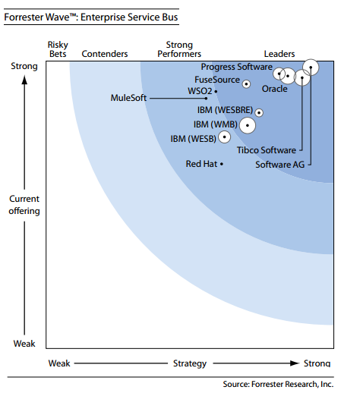

Budget:
Windows server 2012 & Dell Blade Servers (20000 SGD)
Oracle 11g Server (35000 SGD)
ESB (open source)
Application Development Inhouse.

Phase 2:
Application Development Inhouse.

Phase 3:
Application Development Inhouse.

